**Team No: 1**

**Project Title: Resort Management System**

**Team Members**

|  |  |
| --- | --- |
| Name | Student ID |
| Uttam Kumar Saha | 2019000000028 |
| Sanjida Akhter | 2019000000008 |
| Renesha Amin Mayuri | 2019000000063 |

**Benchmark Analysis1:**

**Name of the System:** Fars Hotel & Resort

**Major Features:**

**\***Online Booking system.

**\***View Rooms before booking.

*Customer can find Nearby Transport & Shopping mall from Direction.

*Season based special offer for customers.

*Customer can ask questions and send feedback.

*User can find opportunities of Swimming pool, Fitness FARS, Prominent Health & Spa and Sauna and Steam bath

*Customers can book Convention hall for Meetings and Events purpose.

*Customers can order foods from the Restaurants inside the Resort

**Screenshots:**

Fars Hotel & Resort Home Page

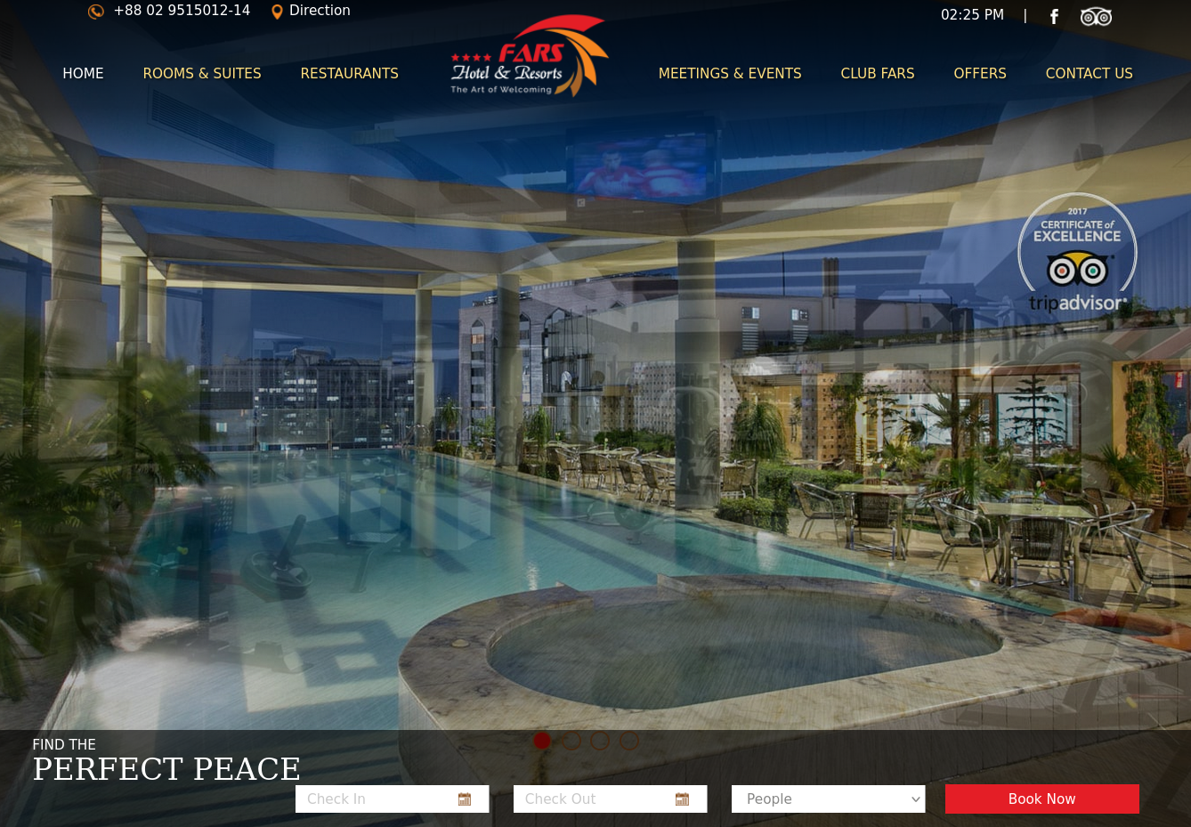

Booking Room Page

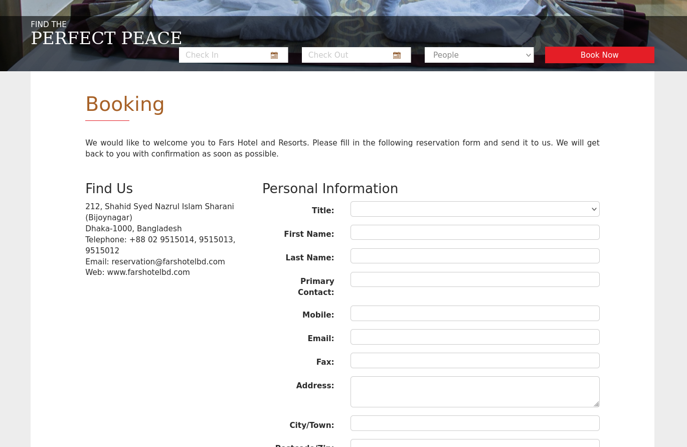

Customers Feedback/Query Form

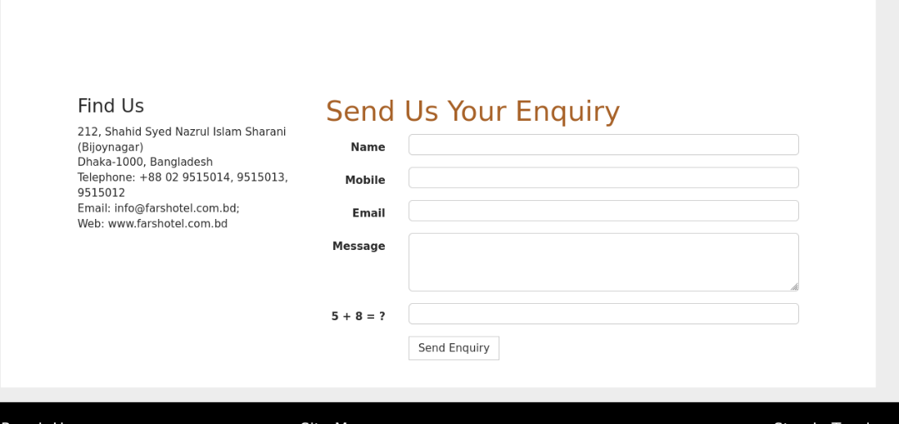

Club Opportunities

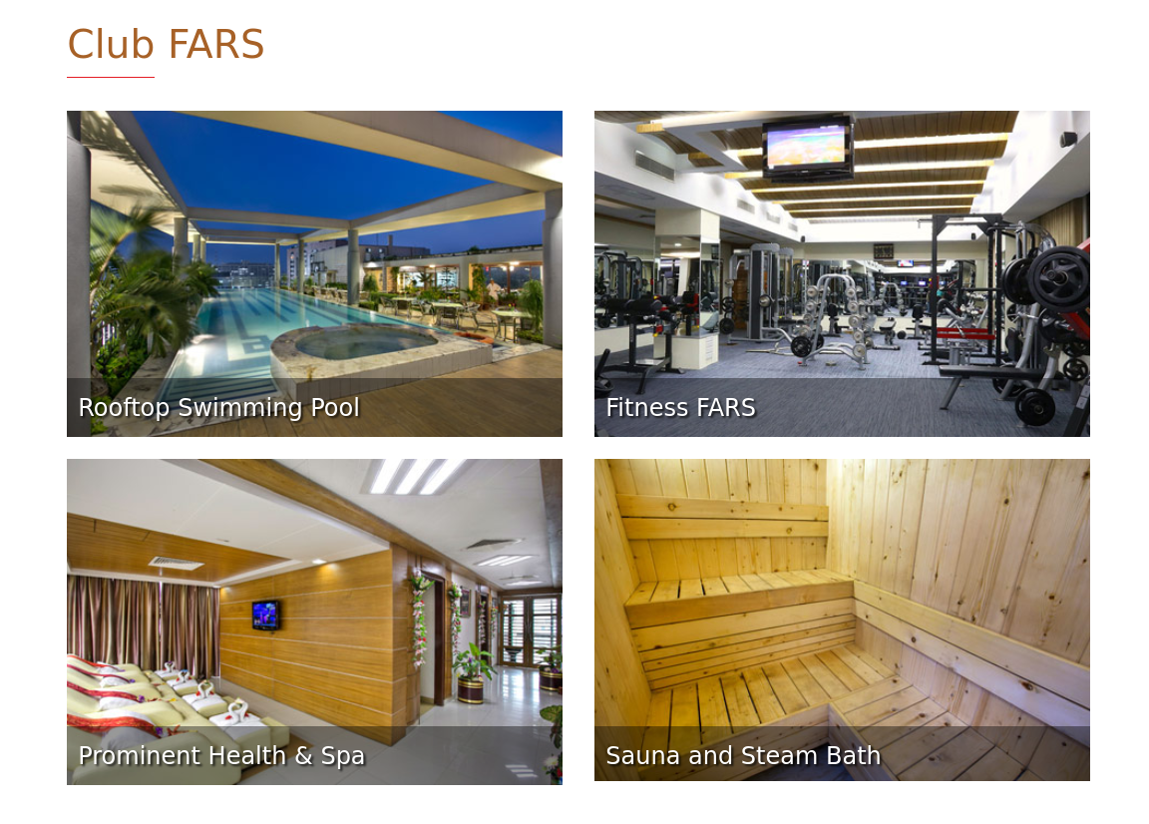

Meeting & Events Opportunity

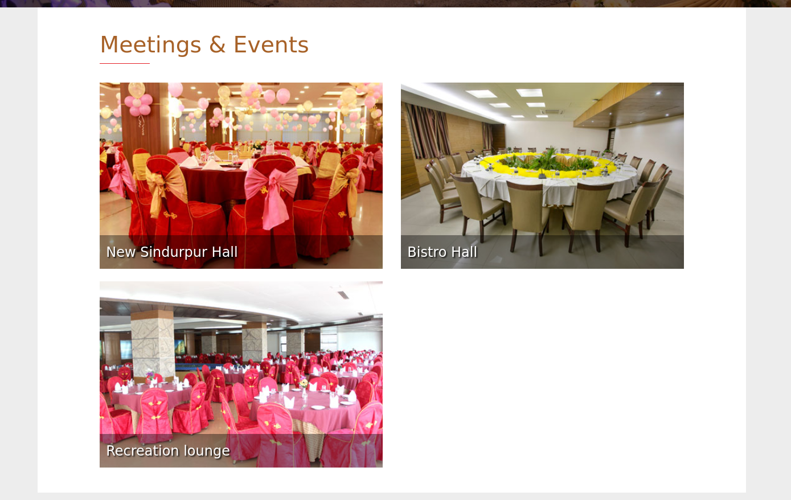

Restaurants opportunity in the Resort

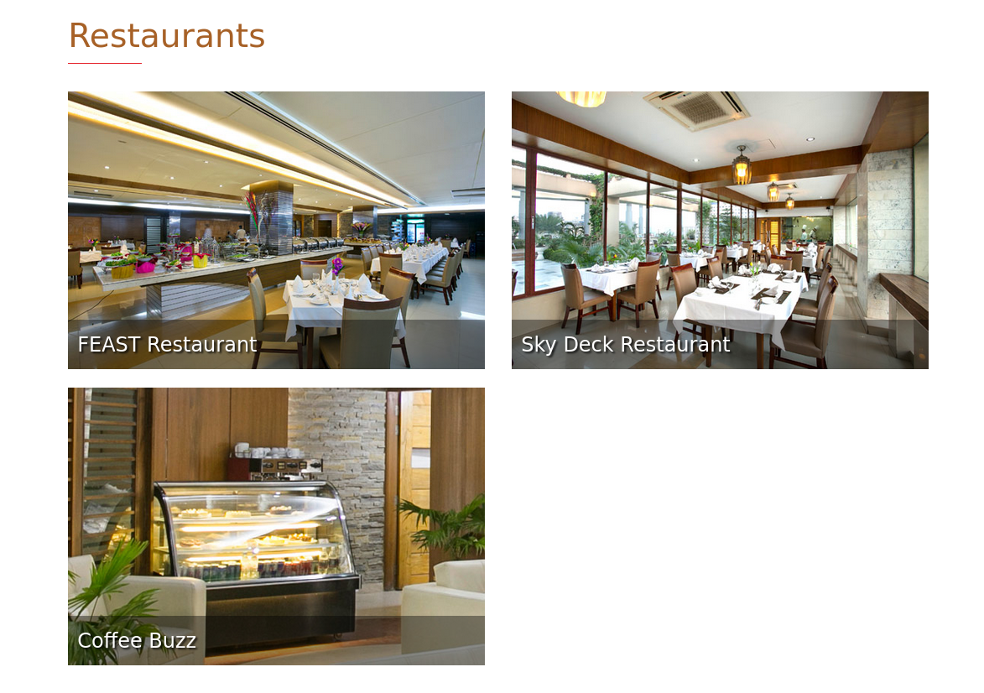

**Drawbacks/Scopes for Improvement:**

*This existing system doesn’t have any search/availability check functionality of rooms, hall and club so that customers can’t understand that the ordered rooms, hall and clubs are available or already booked.

*No authentication and verification for booking rooms anyone can spam or random fake booking rooms and administrator can’t track that.

*No payment options

*User can’t select food items while booking rooms.

*No meeting & events and Hall booking access while booking room that’s why customer have to book these things later manually.

*No Registration/Login opportunities for customers.

*This system is not secure and user friendly.

* There is no surety for availability of rooms

*Customer can’t check their booking status immediately because there doesn’t exist any user login system.

*No notifications management system

*Customer can’t update or make any changes after the booking is done once.

*Customer can’t cancel their order via online.

*The administrator can’t notify customer immediately while confirming customer’s order. They mail/call customer to notify customer’s booking is approved.

**Benchmark Analysis2:**

**Name of the System:** Saptarshi Riverside Resort

**Major Features:**

*Customer can Check Availability of Rooms.

*Choose room

*View Room details

*View Packages details

*Give Feedback to System administrator

*Food menu facilities

*Order processed history

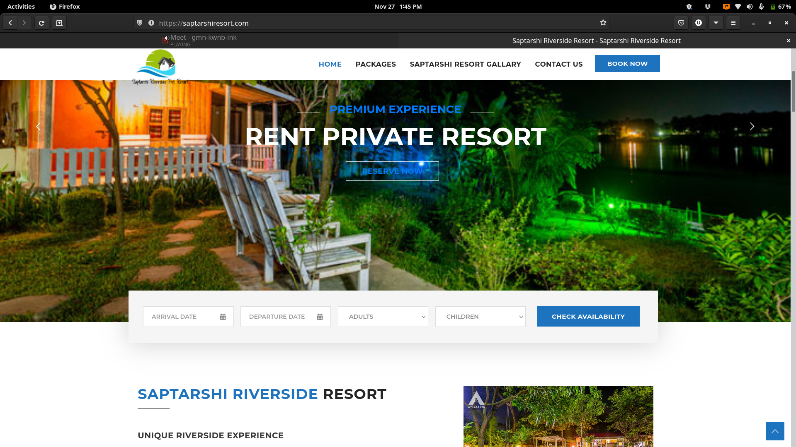 **Screenshots:**

Home Page & Check Availability of Saptarshi Reverside Resort

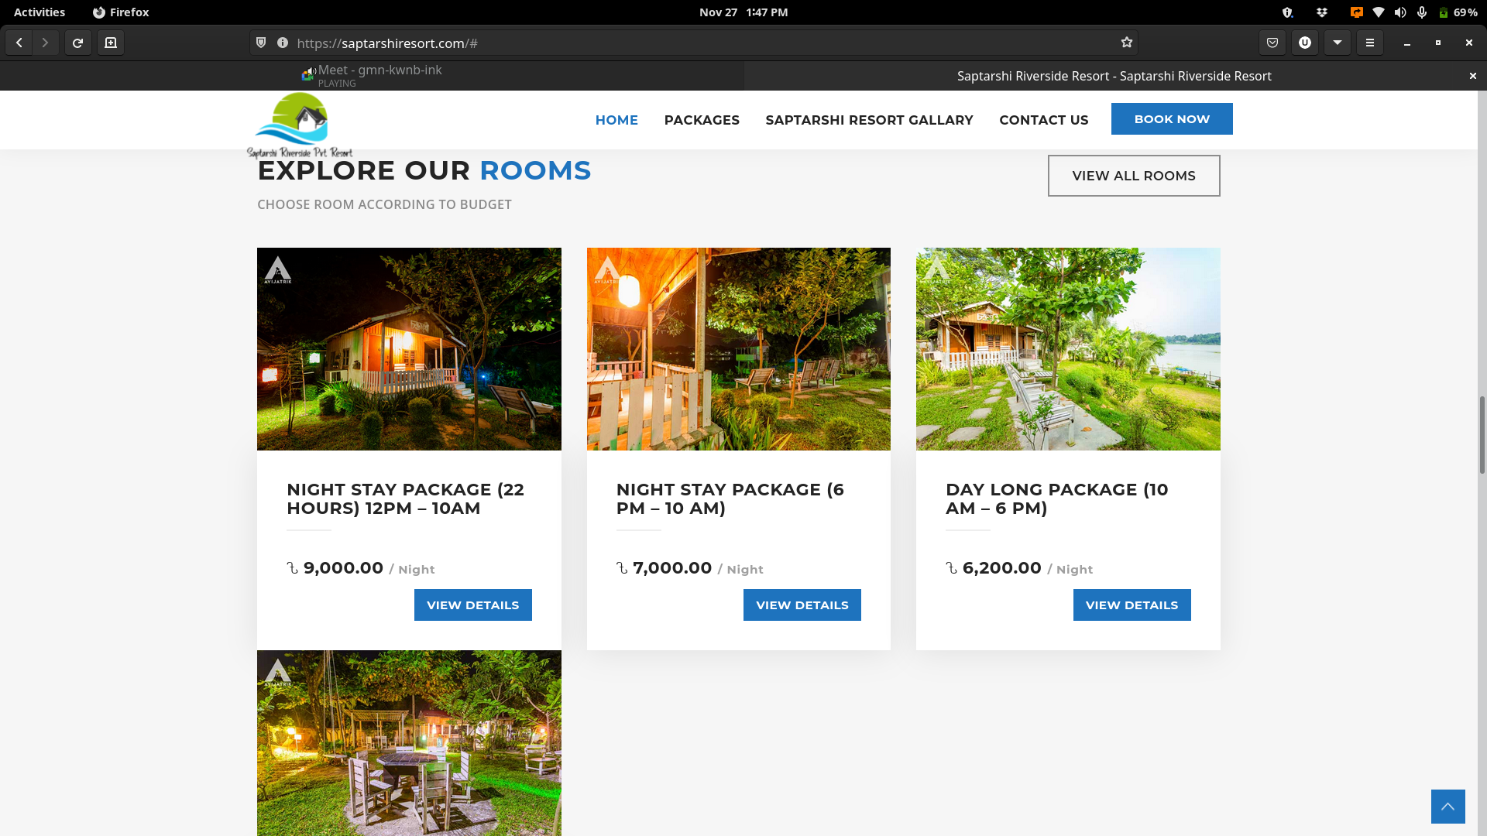

View Room Details & Cost per night

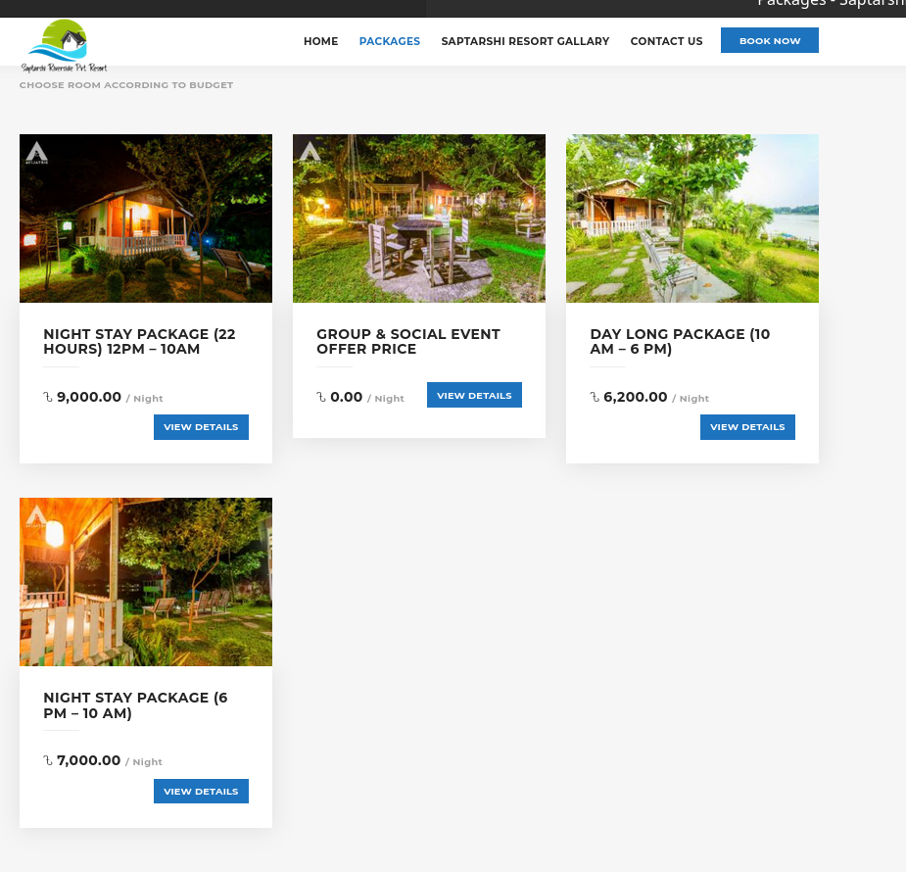

Packages Details

**Drawbacks/Scopes for improvement:**

**\***The existing system is not properly developed. Customers can’t book room online because the functionality/Book button doesn’t work. There is an error while booking.

*Customer can’t choose foods at their own wishes in the breakfast, lunch and dinner while booking room. The resort fixed food menu for each package.

*No online payment system.

*No Registration/Login opportunities for customers.

*Total Features are not accessible

*Provides only room booking facility

*Overall this existing system provide very limited features. Customer can’t access every functionality of this resort via online.

**The features of our system:**

**\***Login system for staff and administrator to maintain customer details and everything.

**\***Registration and Login system for the customers.

**\***Customer can check packages.

**\*** Customer can check Room, Convention Hall availability and available food menu.

**\***Customer can select check-in and checkout dates, number of rooms, number of adults and child while checking availability.

**\***Customer can select room from the availability and they can select what kind of foods/drinks they want to take in the breakfast, lunch, and dinner while booking out of package.

**\***The cost of everything will be generated/calculated automatically based on customer’s selection.

**\***Customer have to make payment while booking, via online banking/mobile banking e.g Bkash, Nagad, Rocket, Credit card, debit card.

**\***Customer can book convention Hall, Select number of people, Select decoration of the convention hall, food menu according their wishes in the breakfast, lunch and dinner. Cost will be generated automatically based on the customer’s selection.

**\***Automated Booking system for the customers. Administrator don’t need to maintain the order approval/processing system. Orders will be approved automatically instantly while customer will pay and confirm booking.

**\***Customer can book swimming pool, fishing, boating facilities.

**\***Customer can order extra foods from the resort’s restaurant.

* Notifications management system.

**\***Customer can send their opinion, suggestion, feedbacks and complaint.

**\***Online virtual assistant or chat bot using AI. Customer can ask their questions there and they will get automatically their answer instantly.

**\***Customer can update or make any kind of changes before 24 Hour of check-in date.

**\***Customer can cancel booking and they will get their money back within short time via online/mobile banking.

**\***Staff can send housekeeping status. Is the room in ready/clean or not.

**\***Only authorized user/customer can access the system. User have to provide accurate data typed value in the registration from field. No one can’t make spam or fake booking randomly because they have to pay online while booking.

*Authentication and Verification system.

Subsystems

|  |  |
| --- | --- |
| Subsystems | Scope |
| Database Management | Customer and Administrator Database, Staff Database, Bookings, Payments |
| Administrator Management | Add Rooms, Add Convention Hall, Manage staff, View room booking, View convention hall booking, View Customer details, Update customer details, Notify Customer, Create Foods, Refund customer payments |
| Client Management | View customer account’s details, Booking and update booking, Cancel booking, Make payments, Feedback, Search available rooms, Halls, Foods. |
| Booking Management | Book Rooms, Book Convention Hall, Food booking, Swimming Pool booking and booking Fishing, Boating facilities. |
| Staff Management | Housekeeping, Serve foods, Guest service, Front desk receptionist, Accountant |

**Difference between proposed system and existing systems:**

There are lot of difference between our proposed system and existing systems.

* There is no Registration and Login opportunities for customer in the existing systems but our proposed system provides Registration and login opportunities.
* There is no payment option in the existing systems but we have online payment system in our proposed system.
* User can’t choose/select foods while booking room in the existing systems but in our proposed system user/customer can choose foods while booking to their own wishes.
* No notification system in the existing systems but our proposed system has notification system.
* User/Customers can’t update or make any kind of changes after booking is done once in the existing systems but in our proposed system User/Customer can update or make any kind of changes after booking is done.
* Customer can’t cancel booking via online in the existing systems but in our proposed system customer can cancel booking and they will get back their money with in short time.
* There is no surety for availability of rooms in the existing systems but in our proposed system user just can see available rooms, convention halls, foods and other facilities
* Customer can’t check their booking status in the existing systems but in our proposed system customer can check all status via user account instantly.
* Anyone can access and can give fake order/booking in the existing systems but only authorized user can access in our proposed system.
* Administrator can’t track user in the existing systems but in our proposed system administrator can track every user.
* Customer can’t check Convention Hall availability and available food menu in the existing systems but in our proposed system customer can check Convention Hall availability and available food menu before booking.
* Customer don’t know what will be the total cost in the existing systems but in our proposed system the cost of everything will be calculated automatically based on the customer’s selection.
* Administrator have to approve customer booking manually in the existing systems but our proposed system is automated Booking system for the customers. Administrator don’t need to maintain the order approval/processing system manually. Orders will be approved automatically instantly while customer will pay and confirm booking.
* There is no online virtual assistant/ chat bot in the existing systems but in our proposed system there is Online virtual assistant or chat bot.
* There are no housekeeping facilities in the existing systems but our proposed system provides housekeeping facilities.